

Standard Data Gateways

Quorum Network Resources Ltd

Robert French

March 2023

# Contents

1. Contents 2

2. Document control 3

2.1. Revision history 3

3. Overview 3

3.1. Introduction 3

3.2. How do they work? 3

3.3. Architecture 3

4. Requirements 4

4.1. Minimum requirements 4

4.2. Recommended 4

4.3. Firewall gateway ports 5

4.4. Related considerations 5

4.4.1. Installation environment constraints 5

4.4.2. Other considerations 5

5. Installing standard data gateway 6

6. Monitoring and optimisation 9

7. Further information 9

8. References 10

# Document control

## Revision history

|  |  |  |  |
| --- | --- | --- | --- |
| ***Version #*** | **Date** | **Reason for release** | **Name** |
| V1 | 1st March 2023 | First Draft | Robert French |
| V2 | 25th June 2024 | Additional instructions regarding catpure of information in IT Boost by service desk. | Robert French |

# Overview

## Introduction

Since Power BI is a cloud service, it requires specific software to be able to access on-premise data sources. The software that allows this secure access to the data in an on-premise data source is the Data Gateway. Additionally, it can be used to access data sources hosted on an Azure cloud environment, for example.

# Installing standard data gateway

Download from this page - <https://powerbi.microsoft.com/en-us/gateway/> the **Standard Mode** data gateway on the machine intended to install the data gateway. Then, open the .exe file, and accept the terms of use. Keep the default installation path, then click the 'Install' button.

In the next window, sign in with an organisation account that has access to the organisation's Power BI service. This account must have at least a Free Power BI account assigned to it, and it would be preferable to have a Power BI Pro account; this is **not** a prerequisite. Note this step ensures the Data Gateway is associated with the organisation's Power BI service.

The next step is to register a new Data Gateway on the computer on which this installer is being run.

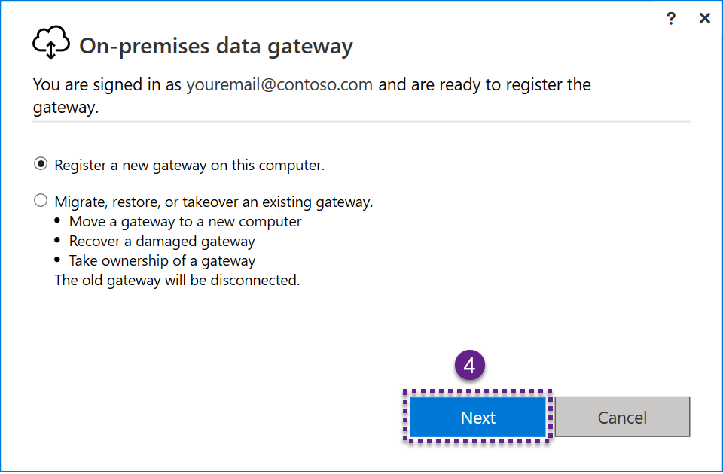

Now enter the name of the Data Gateway that is being installed. Note this should be unique to the Power BI service which it is associated with.

A recovery key must also be entered. The recovery key should be stored in the same way that any passwords are stored. This recovery key will be used to restore the Data Gateway in the event of recovery or moving the Data Gateway. If the recovery key is not provided, all the data source credentials must be re-entered. Once all the relevant details have been entered, click the 'Configure' button.

The final step is to review the information presented in the window displayed. Then, to confirm that the Data Gateway has been configured as intended.

The final screen will look like the one shown below, confirming that the Gateway has been installed successfully and is now running.

# Monitoring and optimisation

There are at least two methods for monitoring the performance of the Data Gateway. One is to monitor the performance counters from the [Windows performance monitoring tool.](https://techcommunity.microsoft.com/t5/ask-the-performance-team/windows-performance-monitor-overview/ba-p/375481)

If the Standard Data Gateway is installed, it is possible to get additional query logging. In addition, Microsoft has created a [Gateway Performance PBI template file](https://download.microsoft.com/download/b/1/b/b1b229f4-a142-4d8a-8968-19e4ae95bc37/OnPremiseDataGatewayLogs.pbit). The template file will allow more significant insights into Standard Data Gateway and the ability to visualise query performance.

More details can be found [on this page](https://learn.microsoft.com/en-us/data-integration/gateway/service-gateway-performance).

# Further information

The Data Gateway, by default, will run under the following service account – 'NT SERVICE\PBIEgwService.'

The following location - *C:\Users\PBIEgwService\AppData\Local\Microsoft\On-premises* is the default location where the Data Gateway spools data. If there is an out-of-disk error, this is one possible reason for that error message. As data is temporarily cached by the Data Gateway when fulfilling a request. For more information, [see this page](https://learn.microsoft.com/en-us/data-integration/gateway/service-gateway-configure-disk-space#gateway-spooling-data).

# References

<https://docs.microsoft.com/en-us/data-integration/gateway/>

<https://docs.microsoft.com/en-us/data-integration/gateway/service-gateway-onprem-indepth>

<https://docs.microsoft.com/en-gb/power-bi/connect-data/service-gateway-onprem>

<https://docs.microsoft.com/en-us/power-bi/connect-data/service-gateway-deployment-guidance>

<https://docs.microsoft.com/en-us/data-integration/gateway/service-gateway-monthly-updates>

<https://learn.microsoft.com/en-us/power-bi/guidance/whitepaper-powerbi-security>

Quorum Network Resources Limited  
18 Greenside Lane, Edinburgh, EH1 3AH

[www.qnrl.com](http://www.qnrl.com/) | [info@qnrl.com](mailto:info@qnrl.com)

Reg. No. SC 196645, Registered Office: 24a Melville Street, Edinburgh EH3 7NS.